31 March 2020

# QA – Week 7 – Day 32

# Docker Multi Stage build

## **Tutorial**

**Expand Java task**

There will be four files in total that will be required for this task.

**Important** thing to note is that the structure has to be as as described, otherwise it will lead to exercise not working.

Make sure that the folder and file names are identical.

Here is an image showing the final structure:

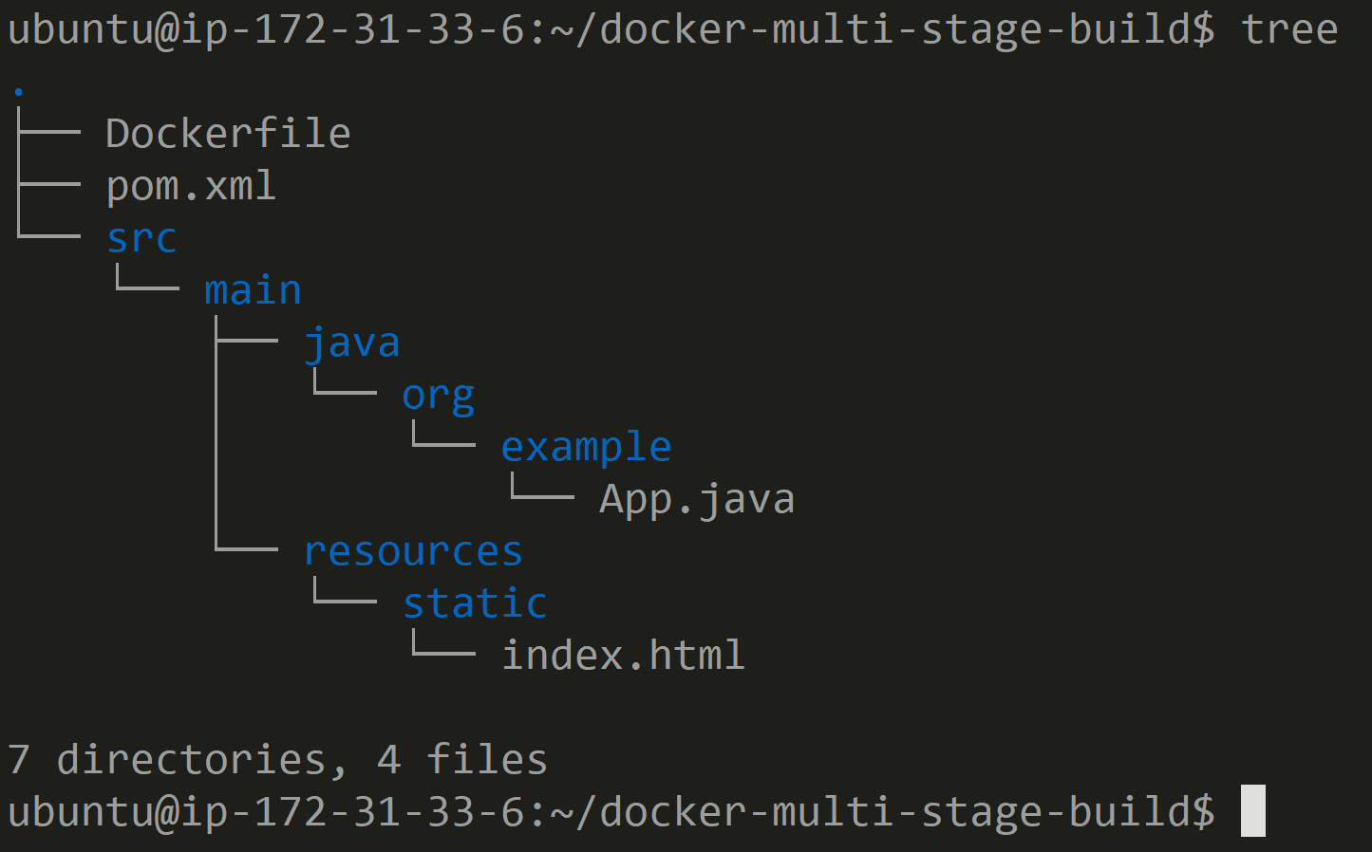

Blue represents folders, white represents files.

**Note** - if you want to retain the formatting when pasting, try **CTRL+Insert**

**Step 1: Create a new directory**

Create a new directory docker_multi_stage_example, command for this is:

**$ mkdir docker_multi_stage_example**

Change to the new directory:

**$ cd docker_multi_stage_example**



**Step 2: Create Java file**

Create the Java application which will run a Spring Boot server, don’t forget to put it in the correct directory.

The filename is HelloWorldApplication.java, make sure you are in the the directory docker_multi_stage_example and then run the command:

**$ mkdir -p src/main/java/com/example/helloworld && touch $_/HelloWorldApplication.java**

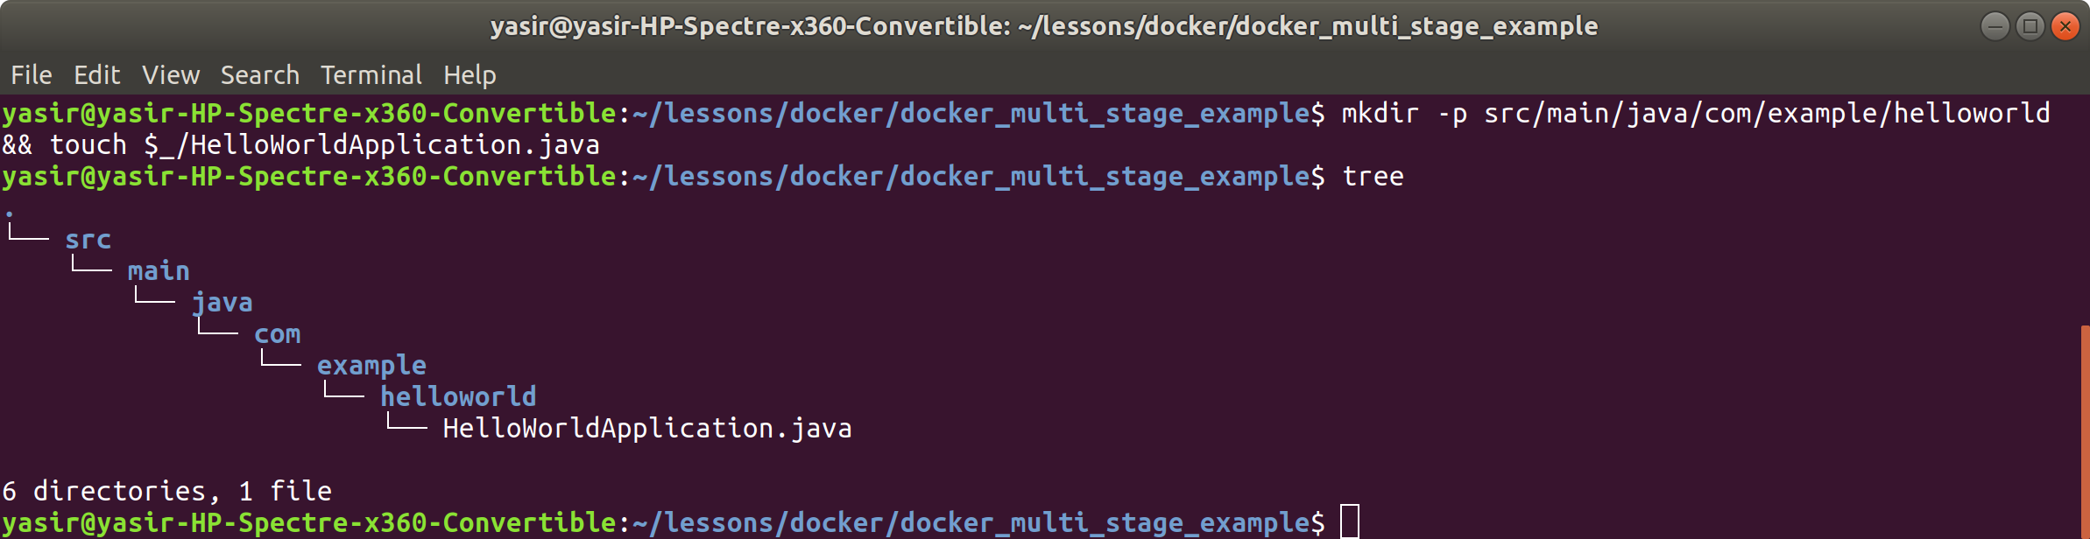

Place the following contents into the *HelloWorldApplication.java* file:

package com.example.helloworld;

import org.springframework.boot.SpringApplication;

import org.springframework.boot.autoconfigure.SpringBootApplication;

@SpringBootApplication

public class HelloWorldApplication {

public static void main(String[] args) {

SpringApplication.run(HelloWorldApplication.class, args);

}

}

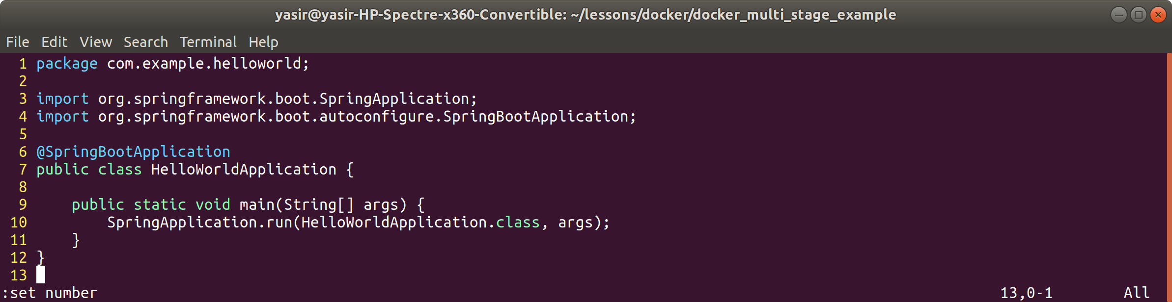

**Step 3: Create static web page**

Just a simple static web page for the application to serve, remember not to forget the folders on this one also.

The filename is index.html, make sure you are in the the directory docker_multi_stage_example and then run the command:

**$ mkdir -p src/main/resources/static && touch $_/index.html**

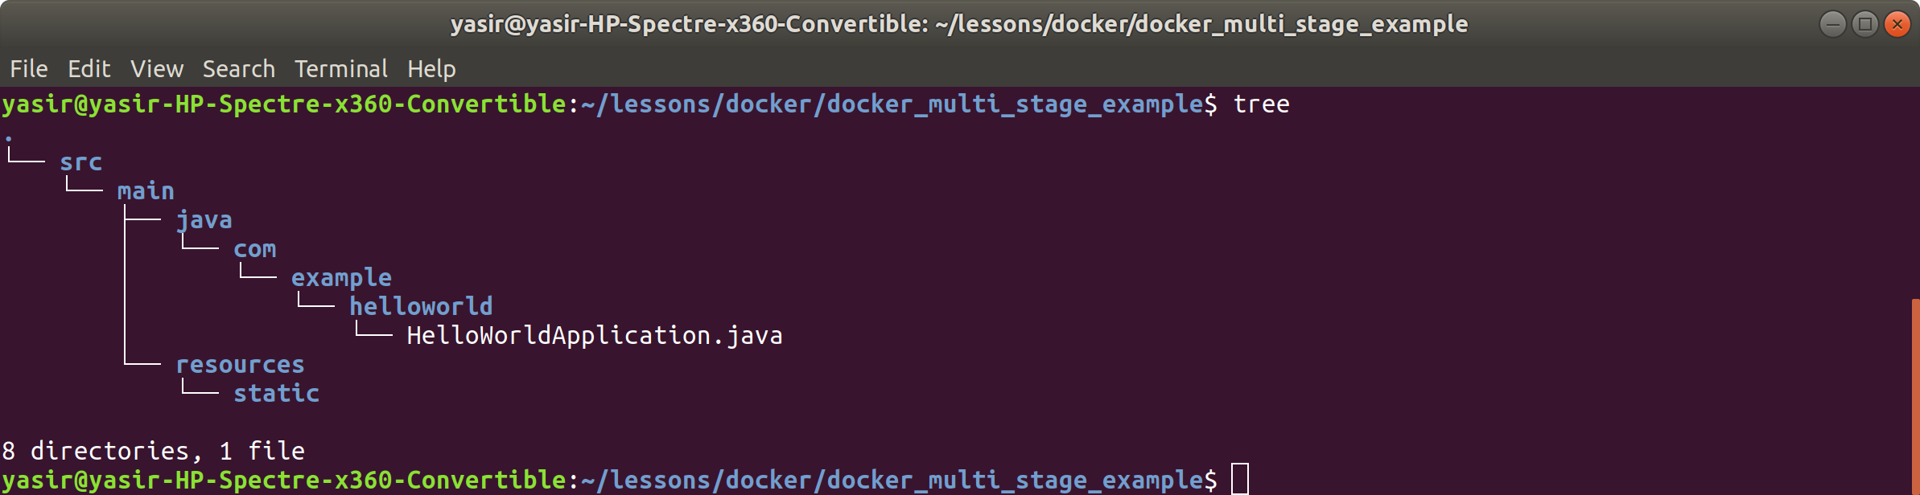

Place the following contents into the *index.html* file:

<!DOCTYPE html>

<html lang="en">

<head>

<meta charset="UTF-8">

<title>Java Spring Boot Server</title>

</head>

<body>

Hello from Docker

</body>

</html>

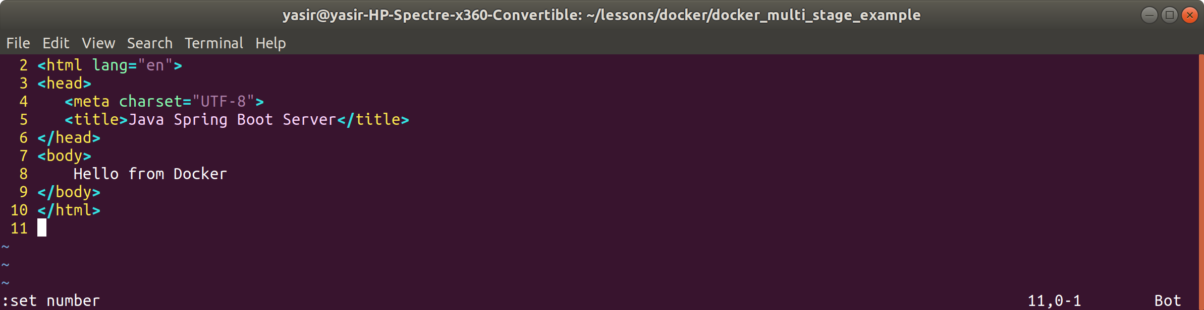

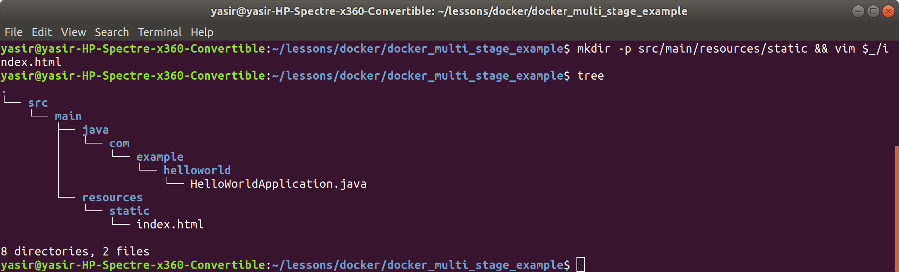

**Step 4: Create configuration file**

For Maven to understand what to compile and how to package the application (a JAR file in our case) we need to create a **pom.xml** file at the root of the project.

Make sure you are in the the directory docker_multi_stage_example and then run the command:

**$ touch pom.xml**

Place the following contents into the *pom.xml* file:

<project>

<modelVersion>4.0.0</modelVersion>

<groupId>com.example</groupId>

<artifactId>hello-world</artifactId>

<version>1.0.0</version>

<packaging>jar</packaging>

<name>hello-world</name>

<parent>

<groupId>org.springframework.boot</groupId>

<artifactId>spring-boot-starter-parent</artifactId>

<version>2.1.0.RELEASE</version>

<relativePath/>

</parent>

<properties>

<project.build.sourceEncoding>UTF-8</project.build.sourceEncoding>

<project.reporting.outputEncoding>UTF-8</project.reporting.outputEncoding>

<java.version>1.8</java.version>

</properties>

<dependencies>

<dependency>

<groupId>org.springframework.boot</groupId>

<artifactId>spring-boot-starter-web</artifactId>

</dependency>

</dependencies>

<build>

<plugins>

<plugin>

<groupId>org.springframework.boot</groupId>

<artifactId>spring-boot-maven-plugin</artifactId>

</plugin>

</plugins>

</build>

</project>



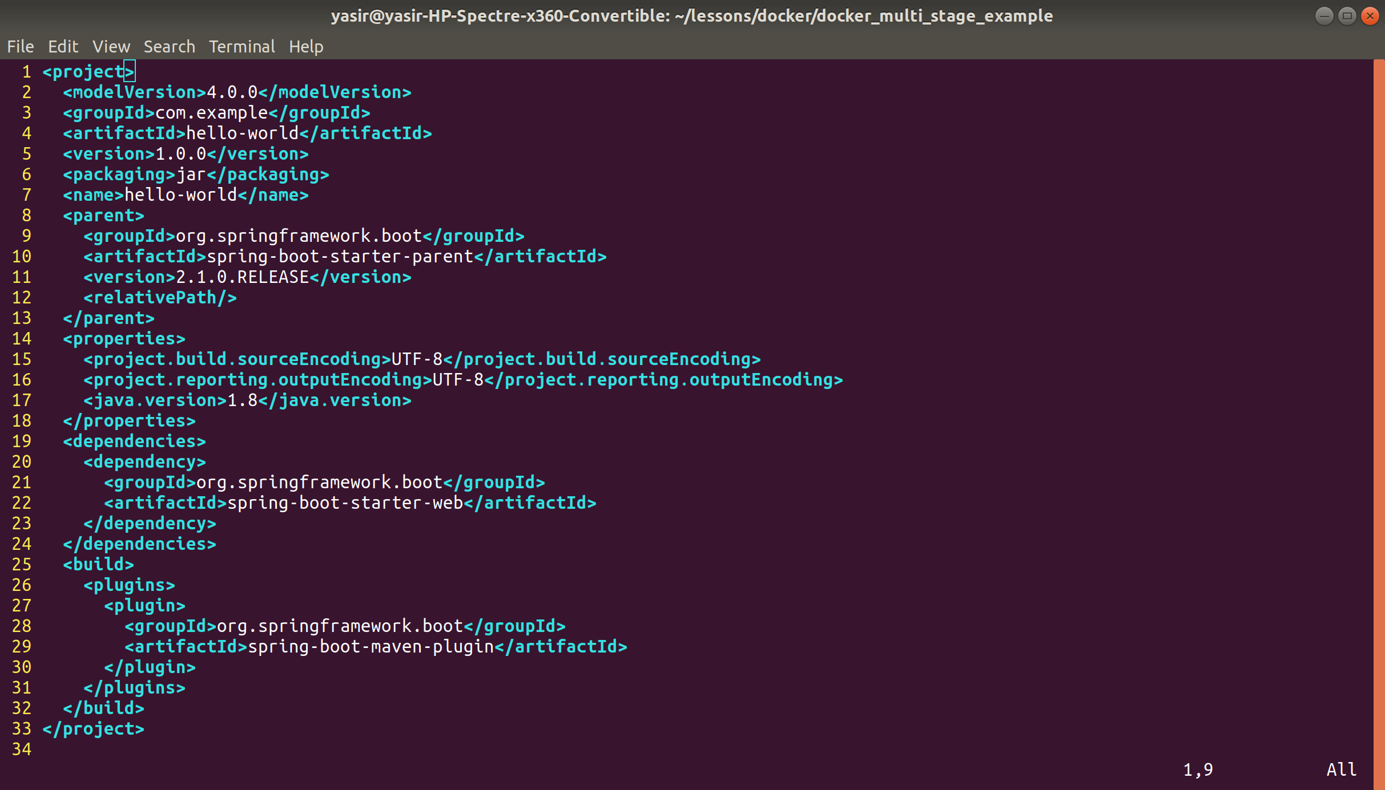

**Step 5: Creating Dockerfile**

The Dockerfile is where we are going to be able to implement the Multistage Build, using a Maven image to compile the code and create a JAR file, then a Java image to run the code in.

Make sure you are in the the directory docker_multi_stage_example and then run the command:

**$ touch Dockerfile**

Place the following contents in the *Dockerfile*:

# build from the Maven image

# which has a maven environment configured already

FROM maven:latest

# copy our application in

COPY . /build

# change the working directory to where we are building

# the application

WORKDIR /build

# use maven to build the application

RUN mvn clean package

# create a new build stage from the Java image

# which has java installed already

FROM java:8

# change the working directory to where the application

# is going to be installed

WORKDIR /opt/hello-world

# copy the JAR file that was created in the previous

# build stage to the application folder in this build stage

COPY --from=0 /build/target/hello-world-1.0.0.jar app.jar

# create an entrypoint to run the application

ENTRYPOINT ["/usr/bin/java", "-jar", "app.jar"]



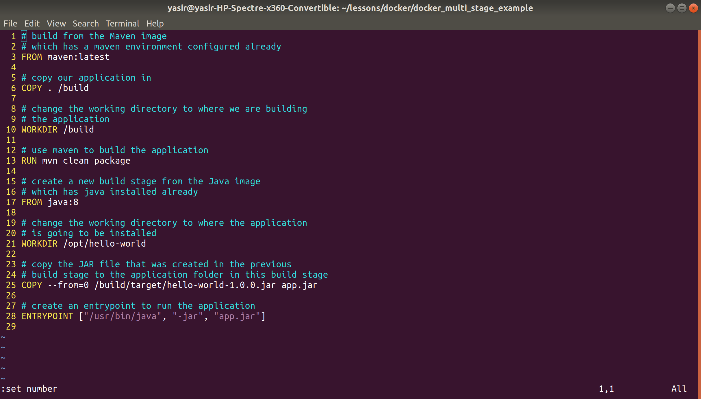

**Step 6: Create the image**

Create the image by executing:

**$ docker build -t my-hello-world-app .**

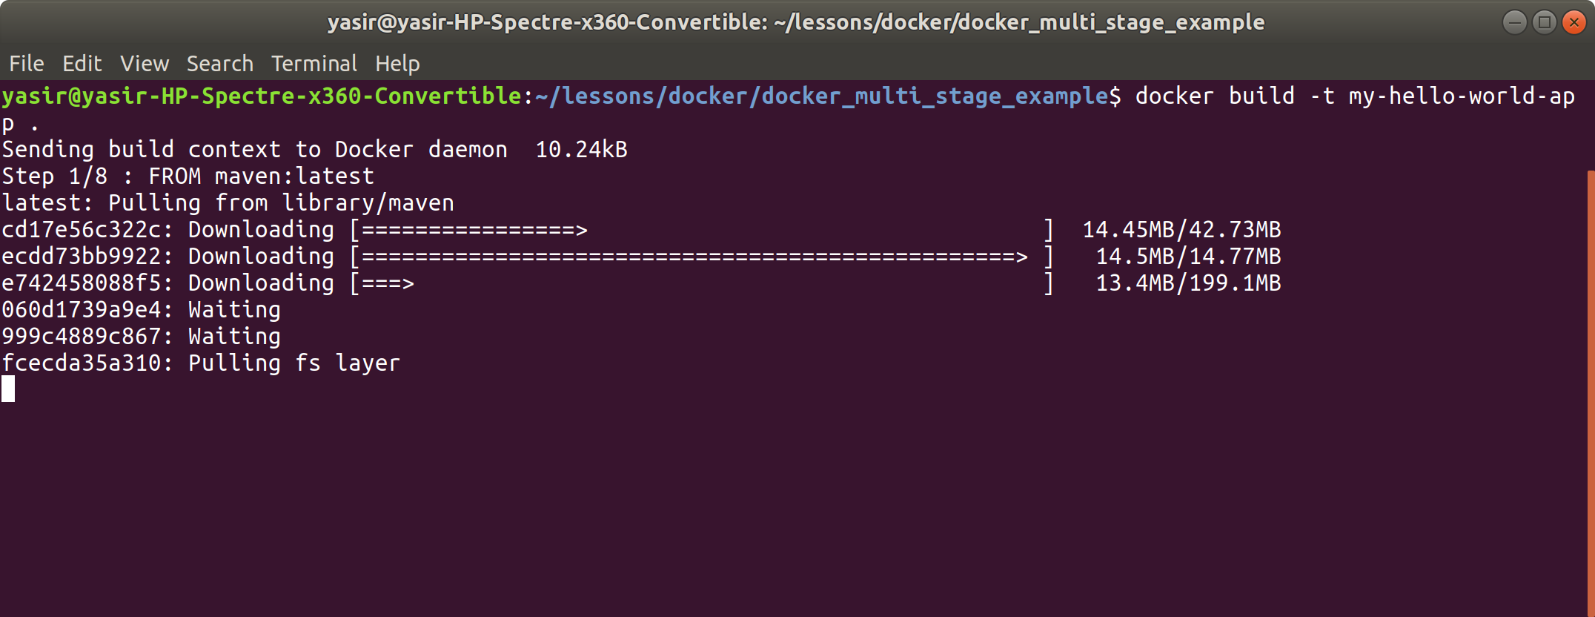

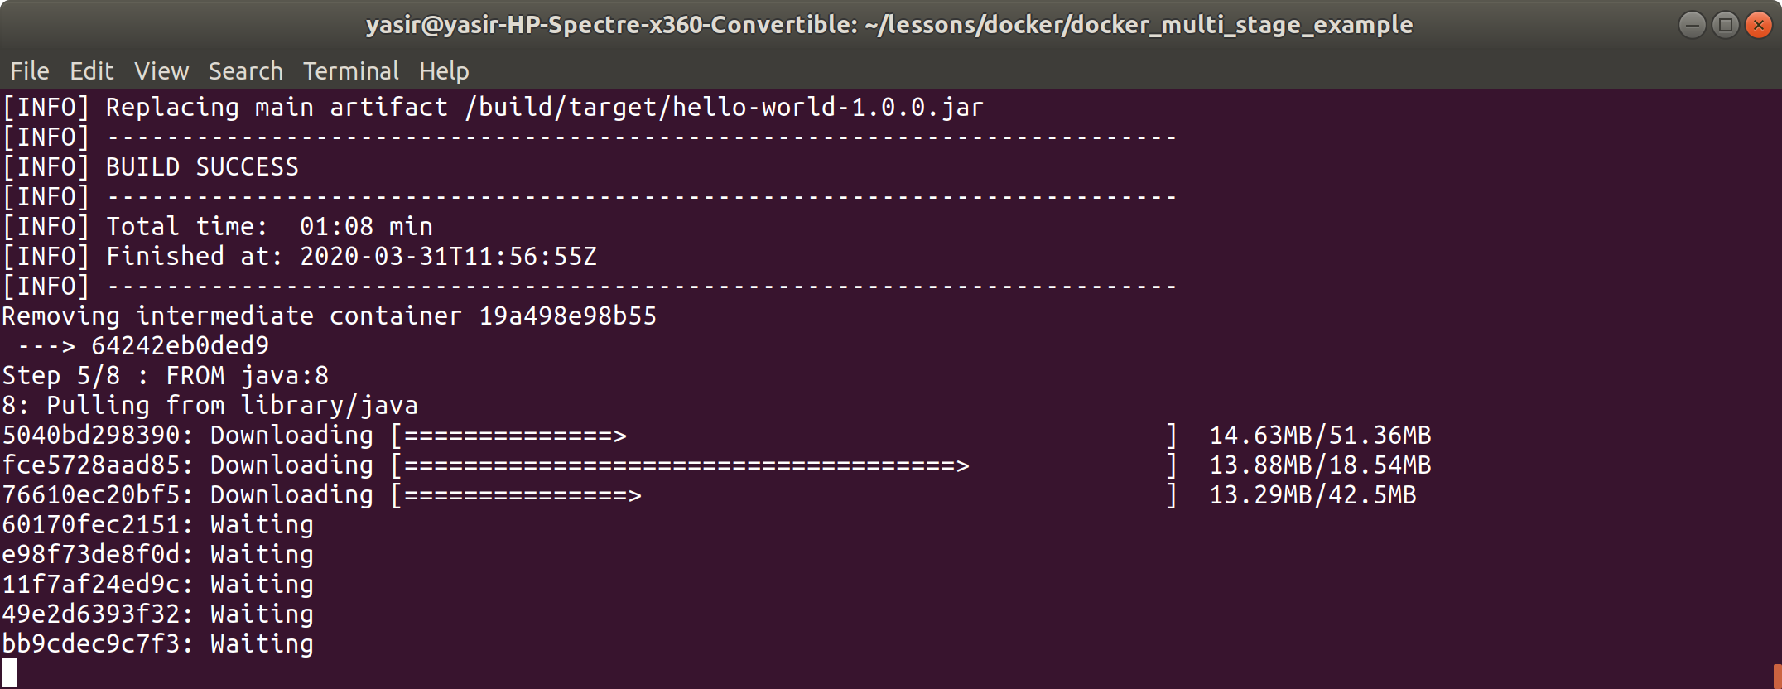

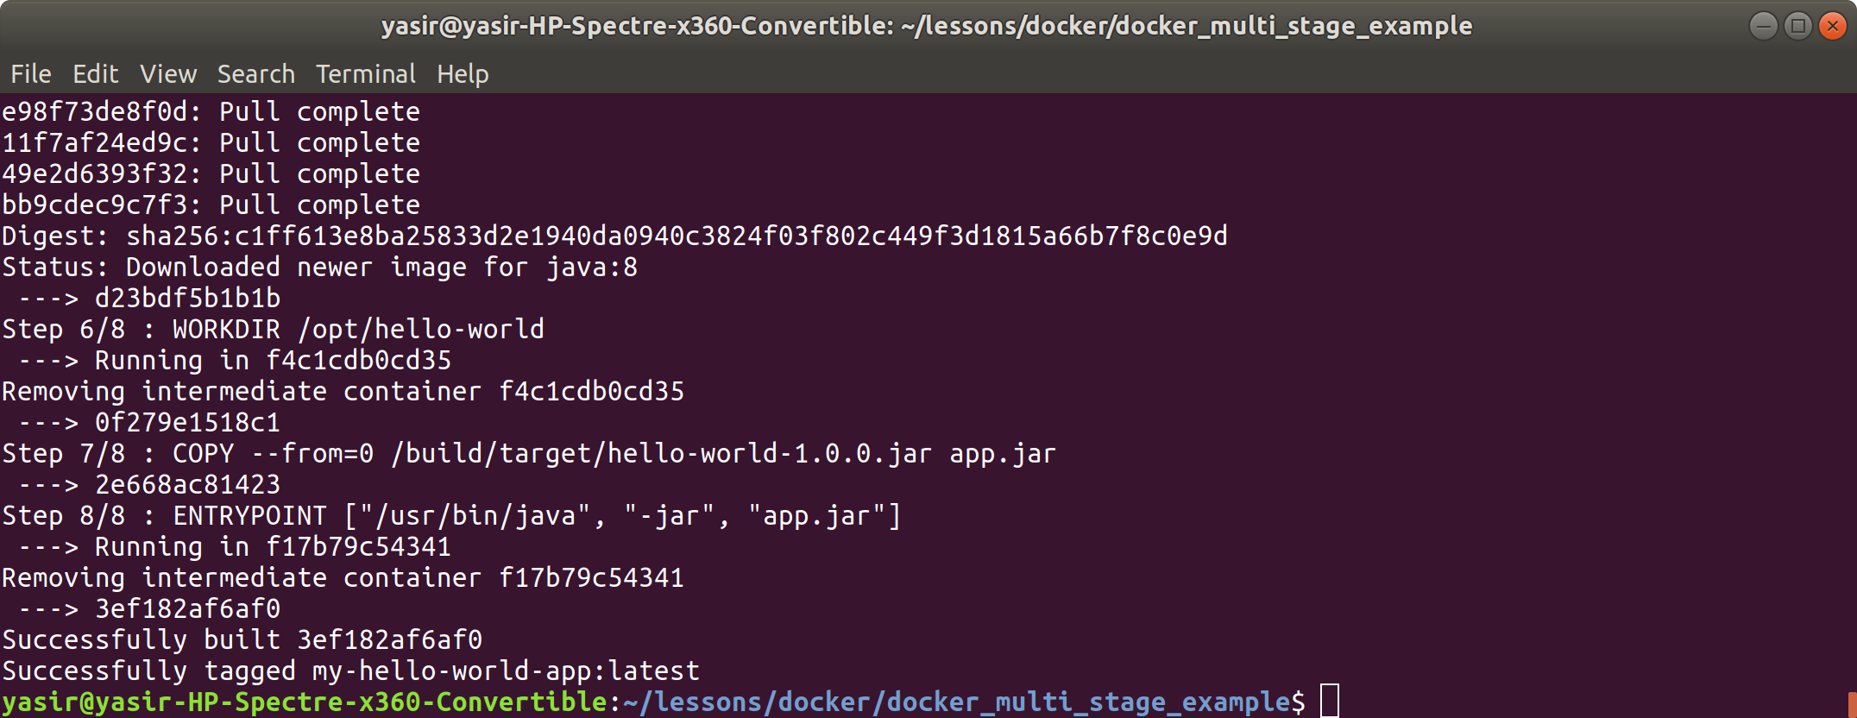

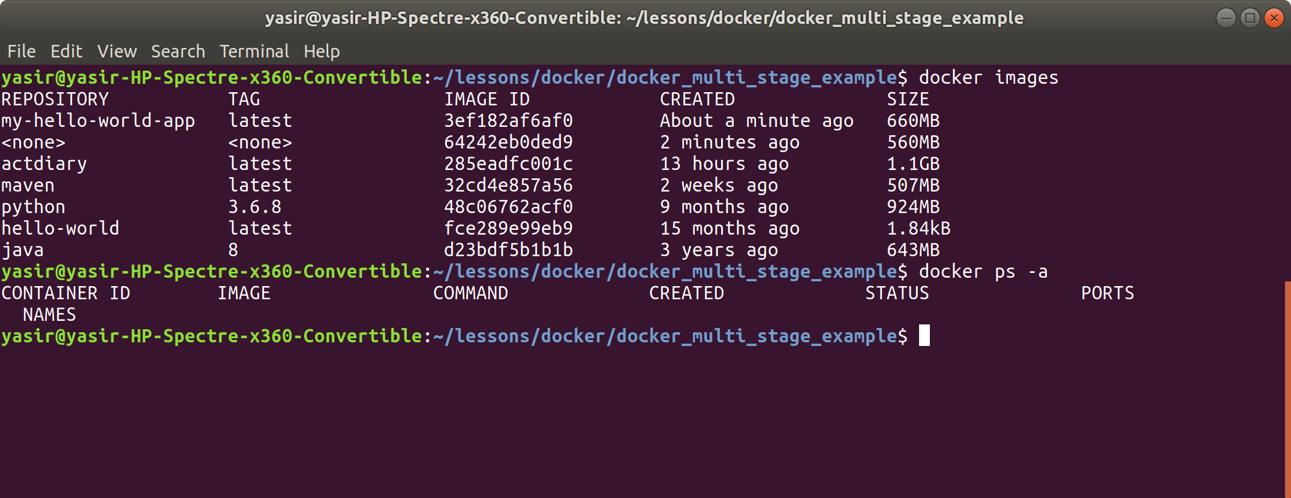

**Step 7: Start the container**

Start the container by executing:

**$ docker run -d -p 8080:8080 --name spring-app my-hello-world-app**

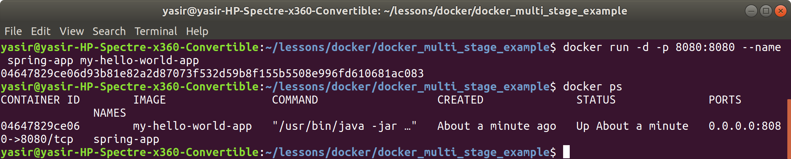

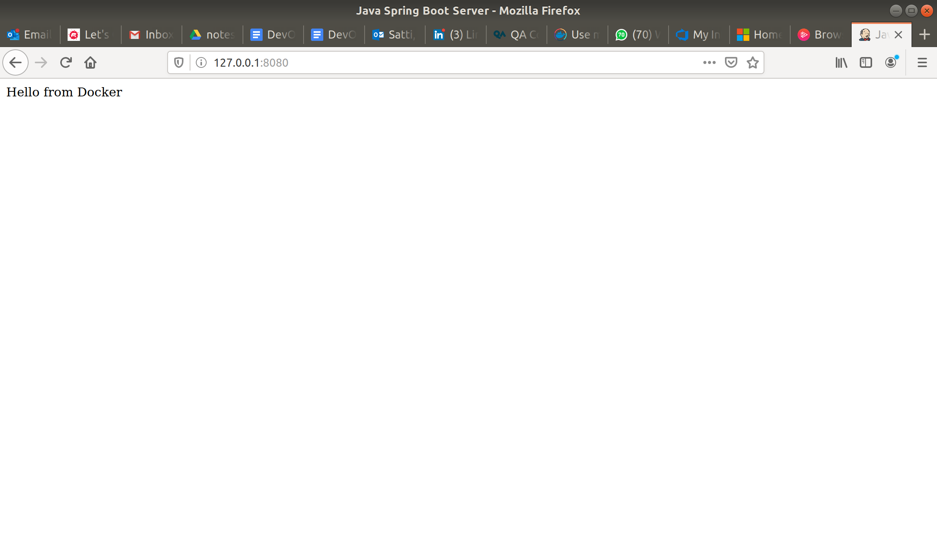

**Step 8: Stop the container**

**$ docker stop spring-app**

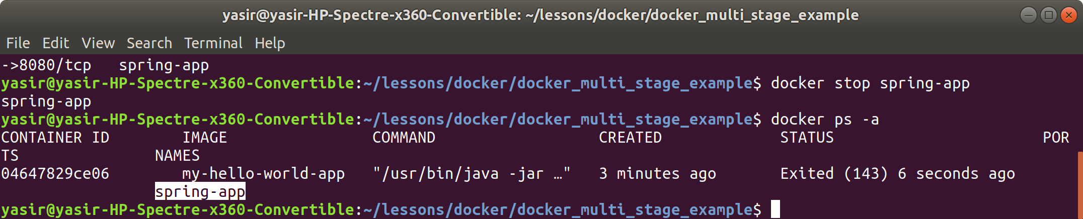

**Step 9: Remove container**

**$ docker rm spring-app**

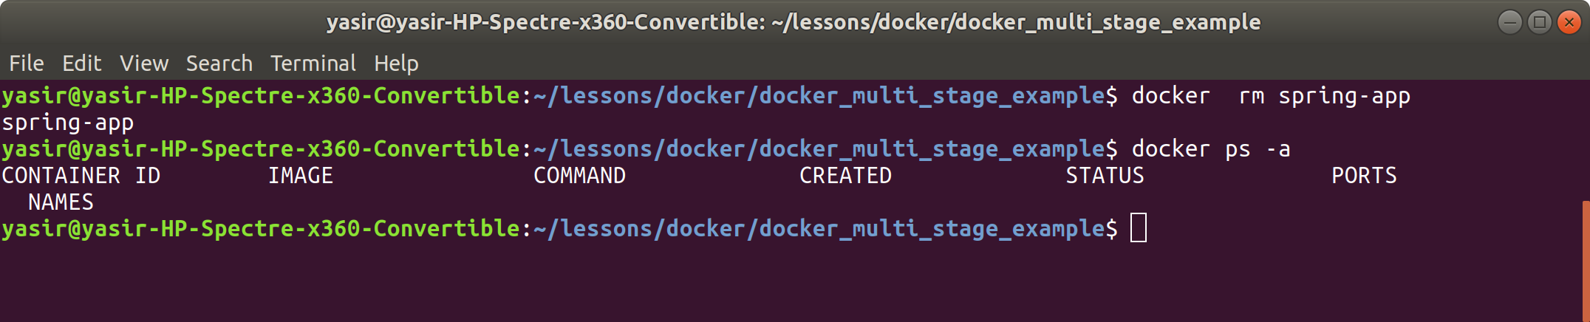

**Step 10: Remove the images**

When prompted for confirmation type y and hit enter:

**docker system prune -a**

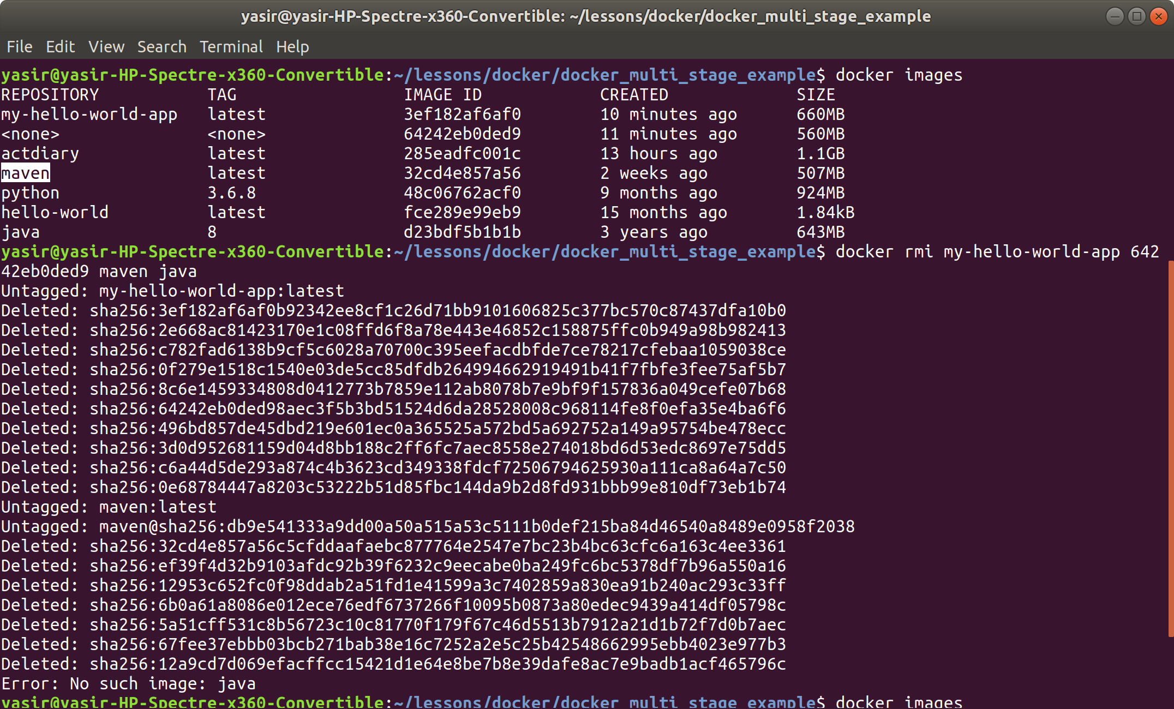

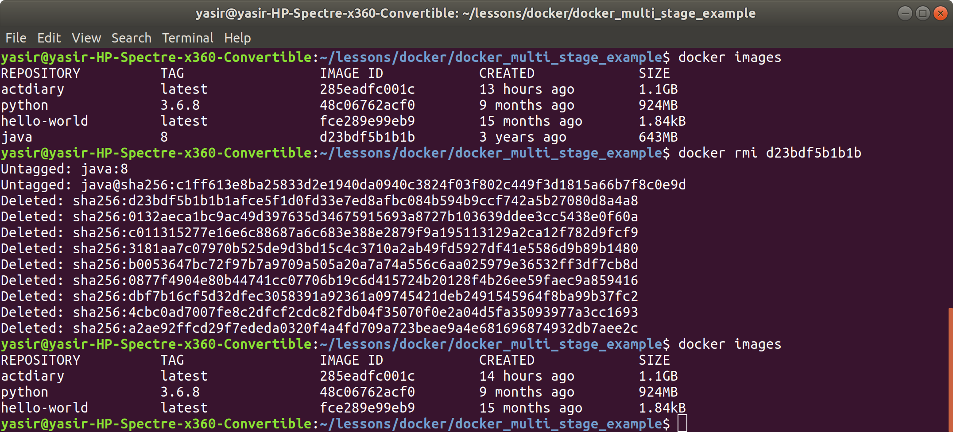

**Expand Java Solution**

You can find the working solution [here](https://github.com/tvaidotas/docker-multi-stage-build).

Once you cloned the repository and have the terminal in the root directory, start at the Create the image step of the Java task.

# Docker Networking

## **Tutorial**

### **Bridge Networking**

This exercise is for demonstrating how the bridge driver in Docker behaves.

With the bridge driver we will configure an NGINX reverse proxy for an application, which will require two containers to communicate with each other.

Requests will go into the NGINX server and then be proxied to the second container.

#### 

#### **Step 1: Setup**

Create a new directory called docker_networking_tutorial and change to this directory:

**$ mkdir docker_networking_tutorial && cd $_**

#### 

#### **Step 2: Create a New Bridged Network**

We'll need to create a new bridged network to put our containers in:

**$ docker network create my-network**

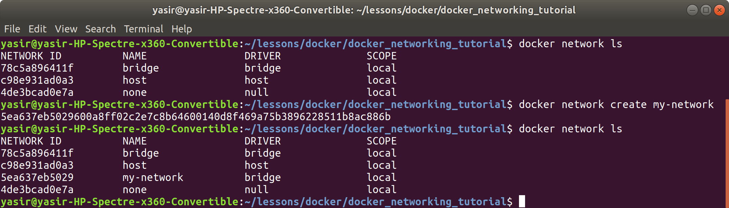

#### **Step 3: Create an Application Container**

For this example we can use Jenkins which is a very popular CI tool that is web based, you may deploy your own application if you wish, just remember to change the NGINX configuration later to use the correct port if you do so.

Create the application container and attach it to the new bridge network:

**$ docker run -d --network my-network --name jenkins jenkins/jenkins:lts-alpine**

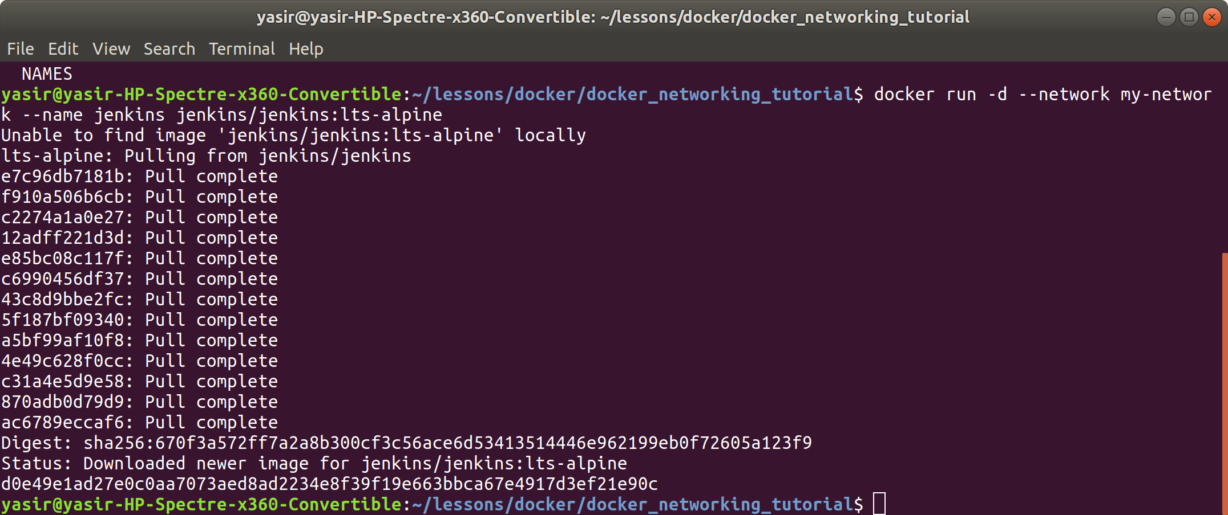

#### **Step 4: Create an NGINX Configuration**

NGINX is another very popular tool that can address many networking issues, we’ll be using it for it’s primary purpose here, as a reverse proxy.

We’ll need create our own configuration file for this (nginx.conf) and enter the following:

events {}

http {

server {

listen 80;

location / {

proxy_pass http://jenkins:8080;

}

}

}



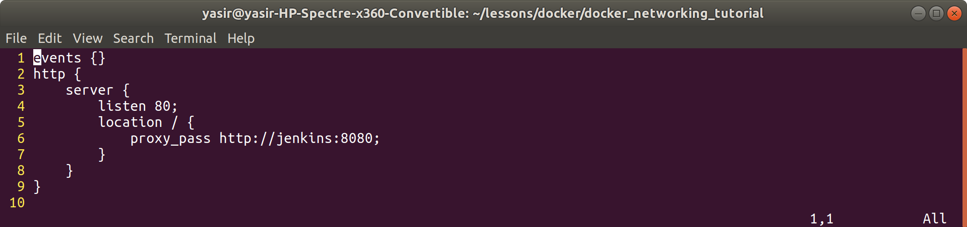

Without needing to understand NGINX a great deal we can see here that proxy_pass is referring to the jenkins container by its name jenkins, not an IP address.

This name jenkins will be resolved to the current IP address of the jenkins container.

#### **Step 5: Create an NGINX Container**

We are going to pass in the configuration that we made as volume to the container, this module doesn't explain what this is, however all you need to know at this point is that it gives the container access to the configuration file that we just created.

The NGINX container that we create must also be attached to the network we made earlier. We’ll also publish port 80 we can access NGINX from outside of the bridge network.

Here's the command to do it:

**$ docker run -d --network my-network -v $(pwd)/nginx.conf:/etc/nginx/nginx.conf -p 80:80 --name nginx nginx:alpine**

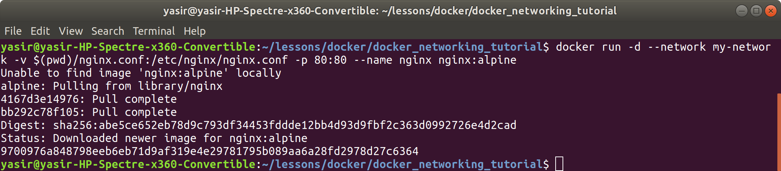

**Step 6: Accessing Application**

You should now be able to access your application from the host (http://localhost), or if it a remote server with port 80 opened on the firewall you can just access your application via the public IP address.

accessing **localhost:80** on the web browser result

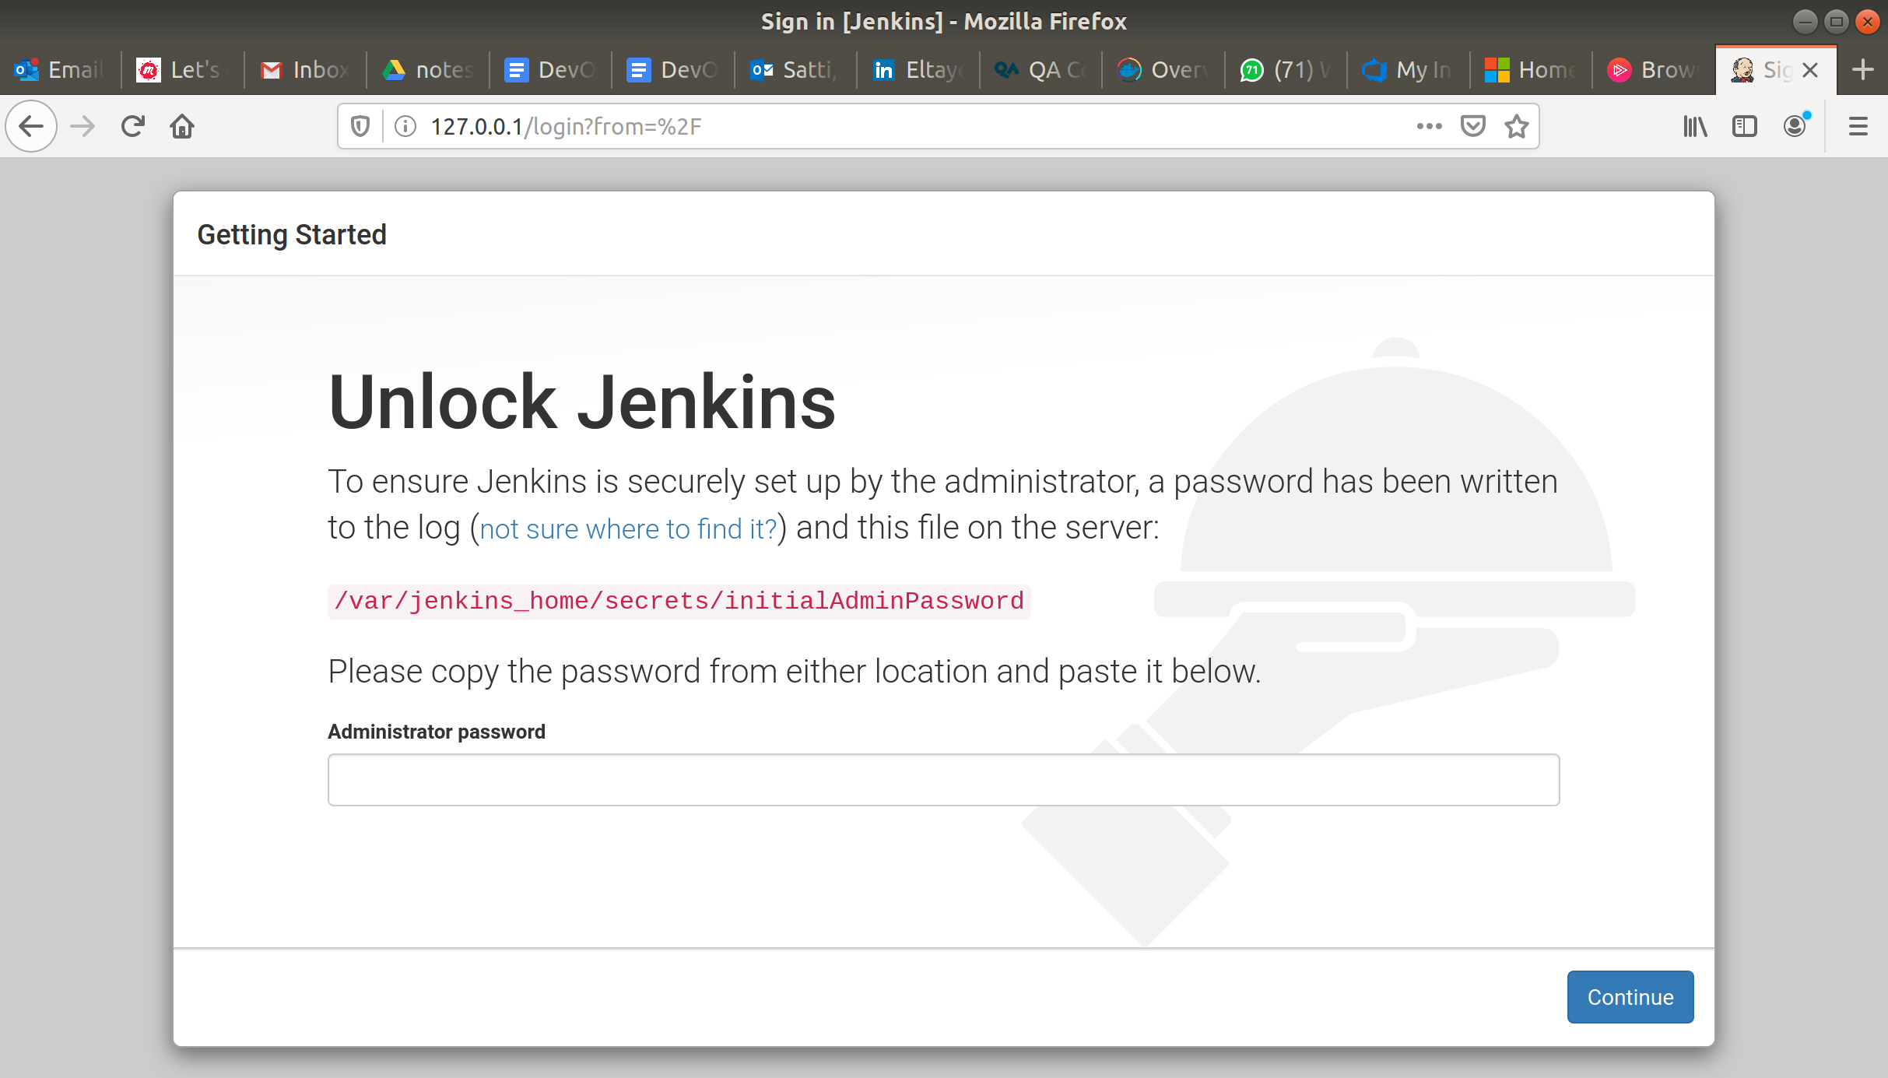

You should see something like this:

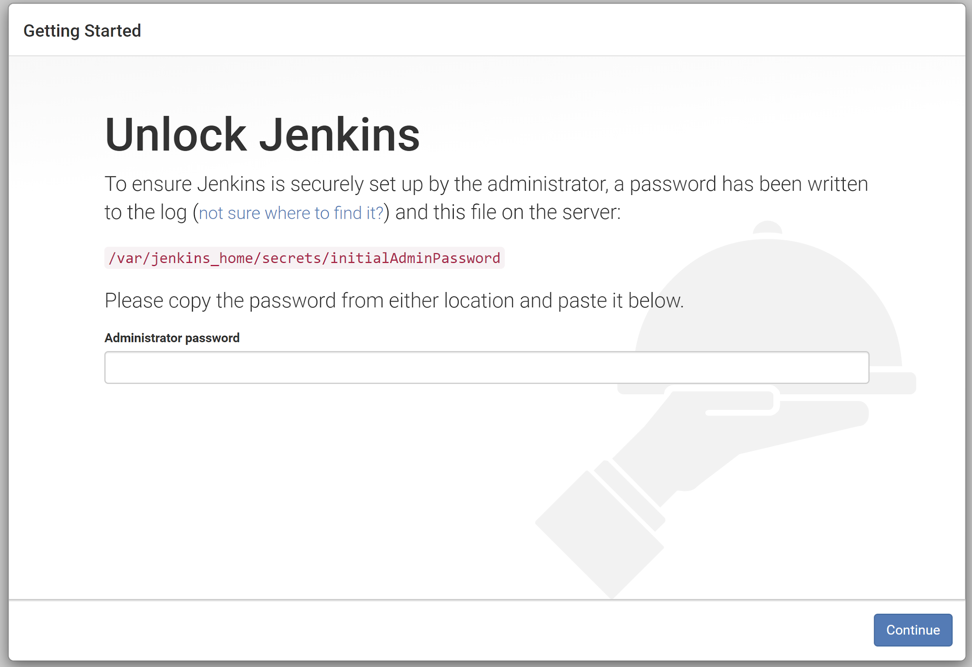

You can also check it through the terminal by executing the following command, replacing localhost with the public IP address if you want to test connectivity over the internet:

curl localhost

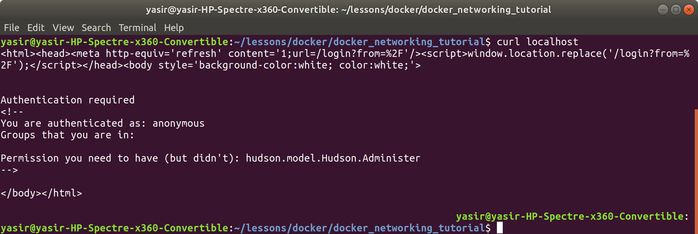

You should see something like this:

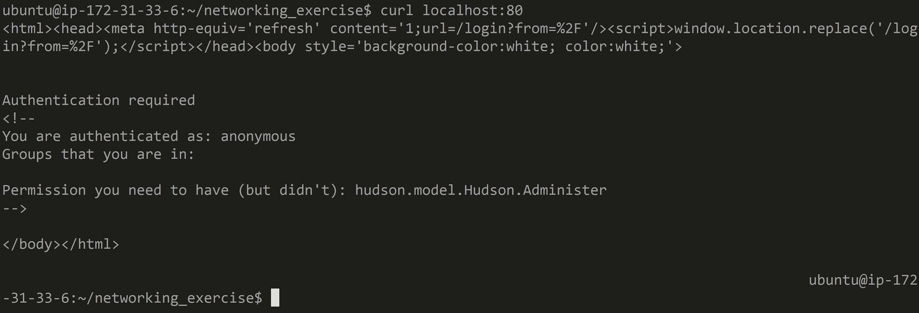

#### 

#### **Summary**

When you connect to your application, traffic is going through NGINX first, it is then routed to your deployed application even though they are in separate containers.

This made possible because both the containers are on the same bridge network.

#### **Step 7: Clean Up**

Stop and remove the containers by executing:

**$ docker stop -f jenkins nginx**

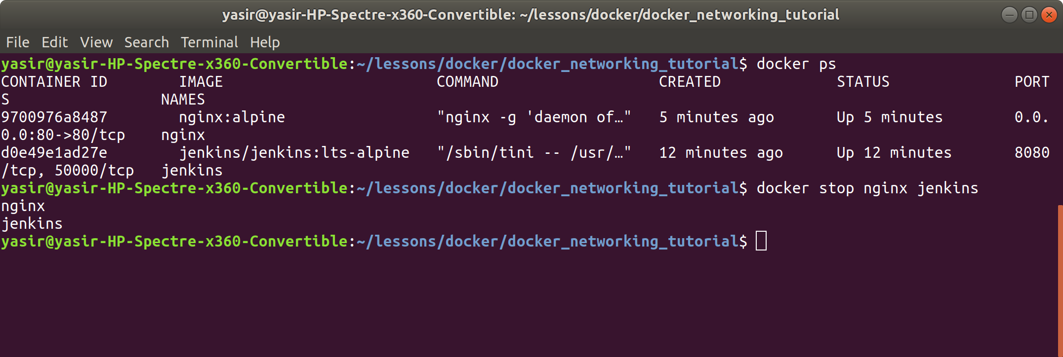

**$ docker rm -f jenkins nginx**

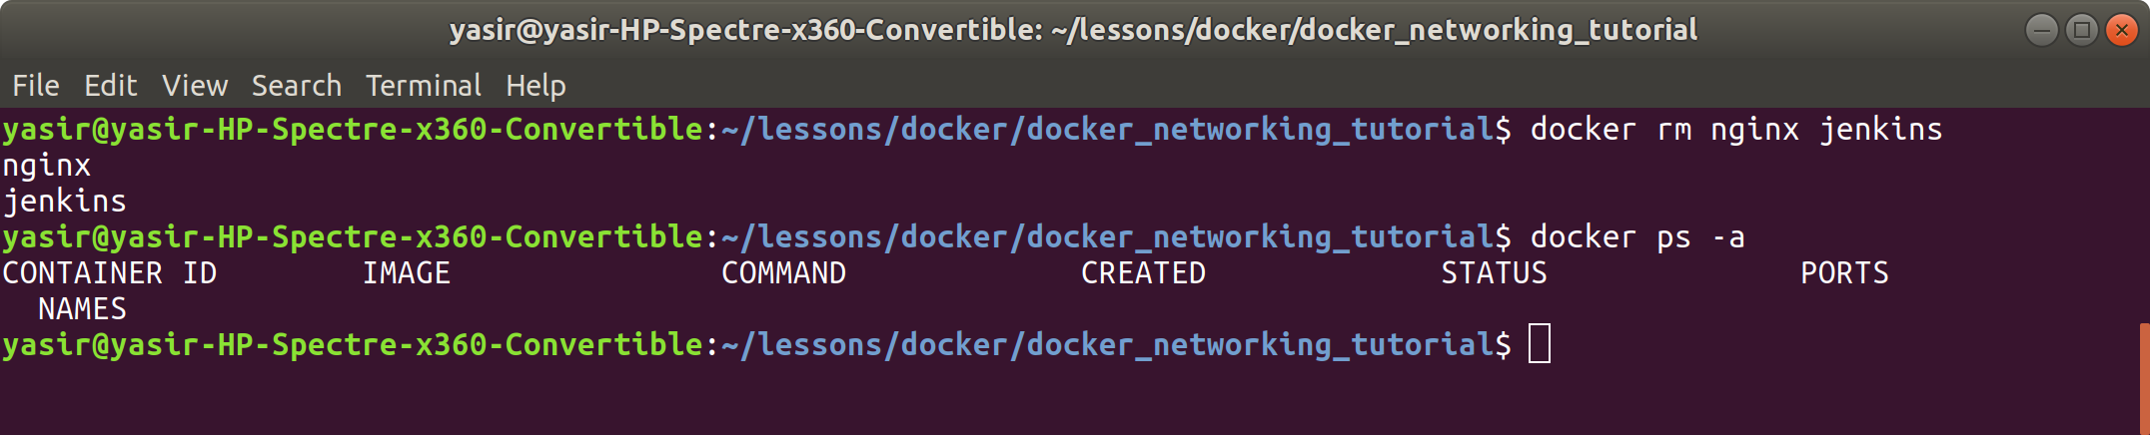

Remove images by executing:

**$ docker rmi nginx:alpine jenkins:lts-alpine**

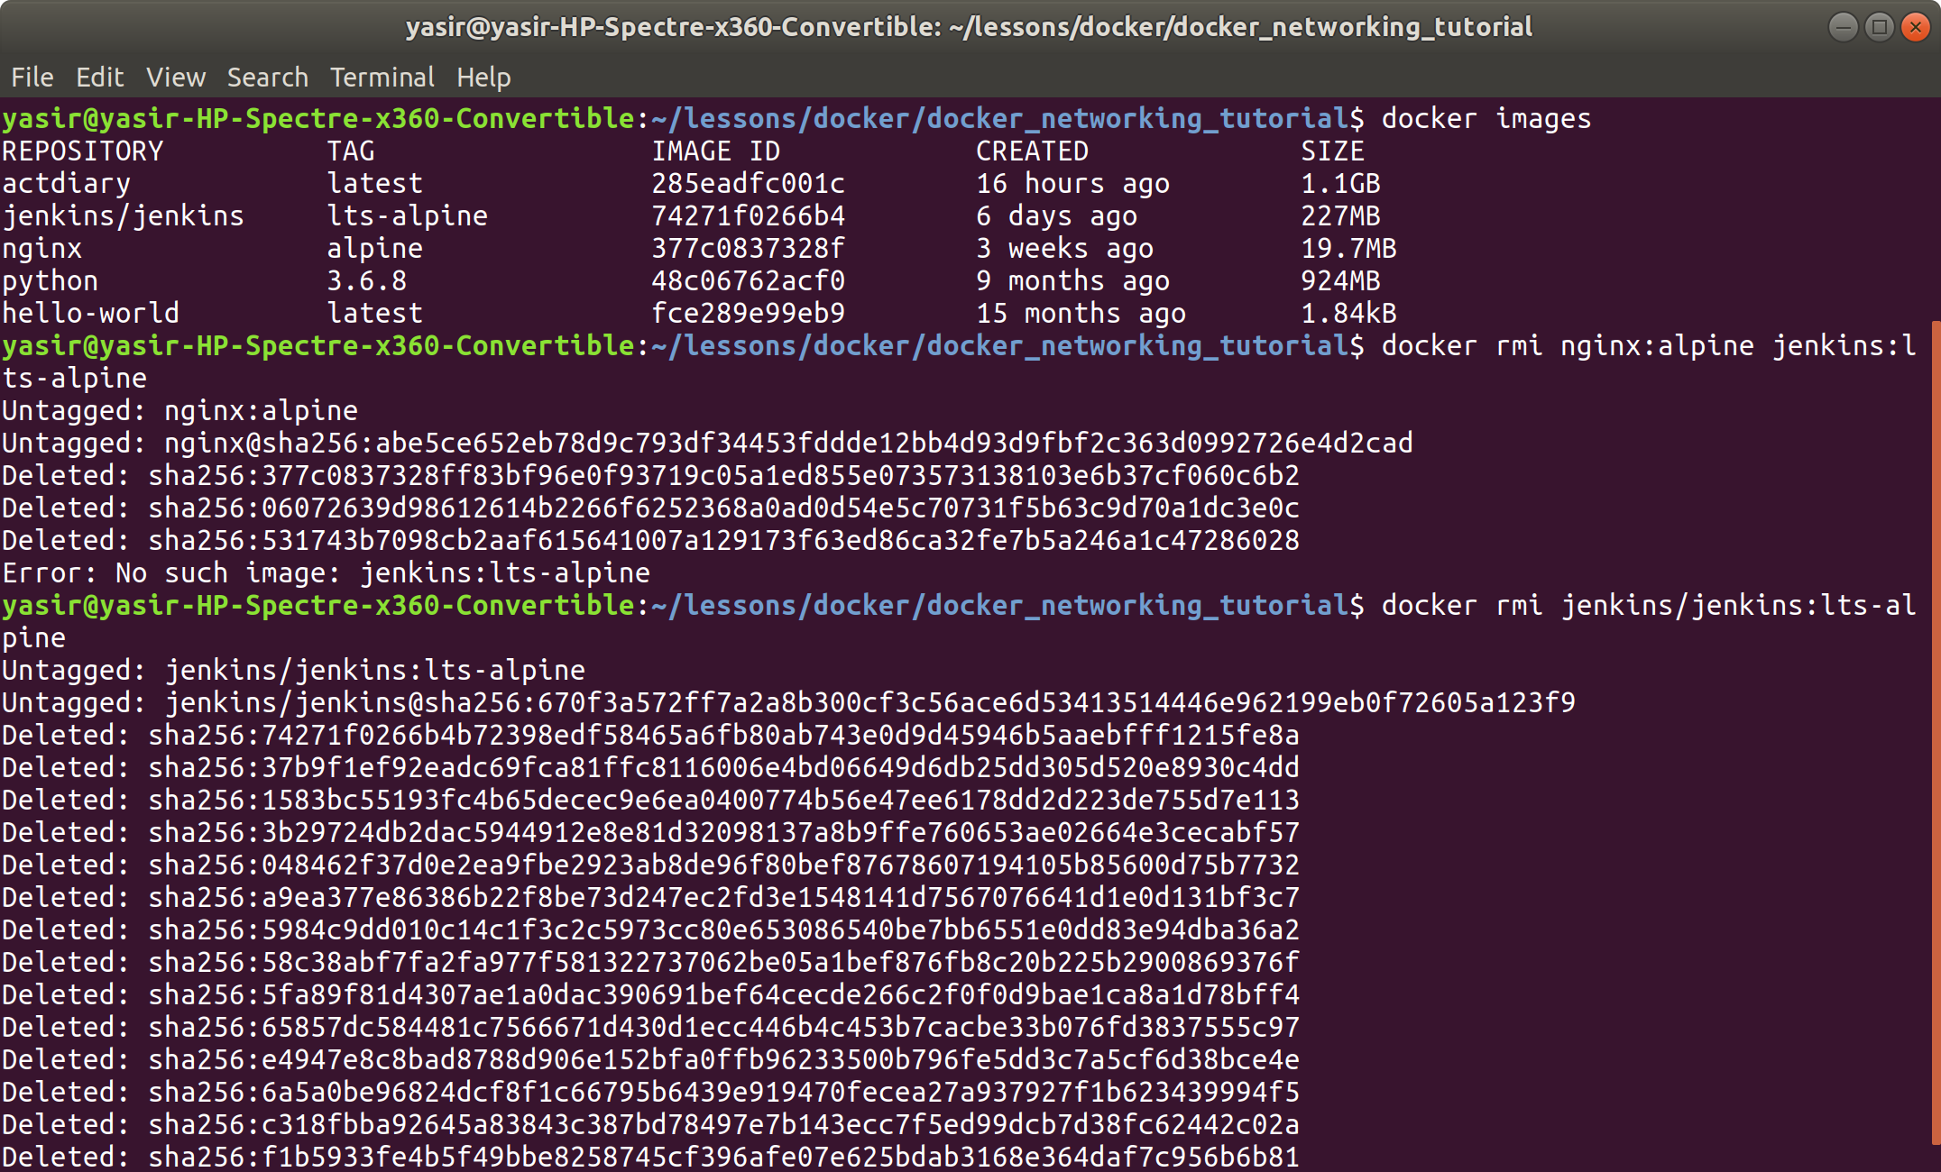

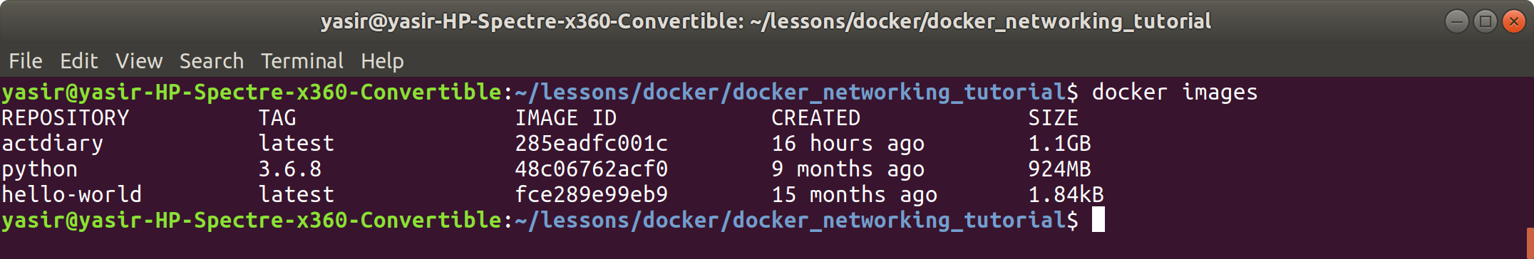

## **Exercises**

Try to get one of your projects to work now, for instance a server that connects to a database, or a front end application that connects to a server using Docker networks.

# Docker Registry

## Tutorial

Expand guided task

This exercise will take you through creating your own registry that you can push and pull images to.

**Step 1: Create the registry**

Start by creating the Registry and make sure that the port 5000 has been published.

The command for it is:

**$ docker run -d -p 5000:5000 --name registry registry**

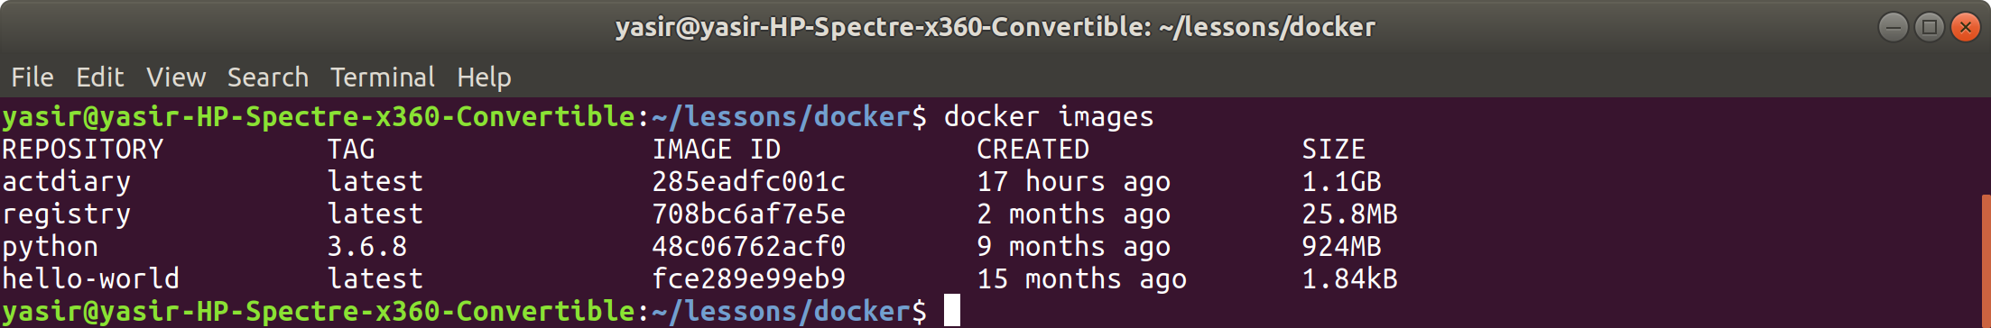

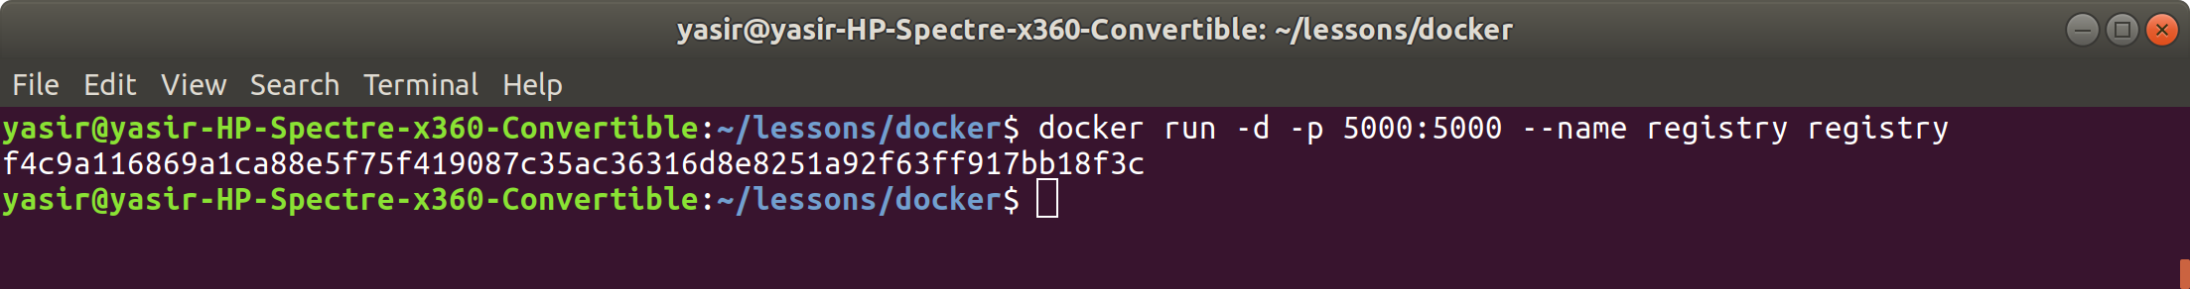

**Step 2: Upload an Image to the Registry**

To upload an image to the Registry, we first need one that has been tagged appropriately.

Start by pulling an NGINX down.

**$ docker pull nginx:latest**



Re-tag it to be localhost:5000/my/nginx.

**$ docker tag nginx:latest localhost:5000/my/nginx**

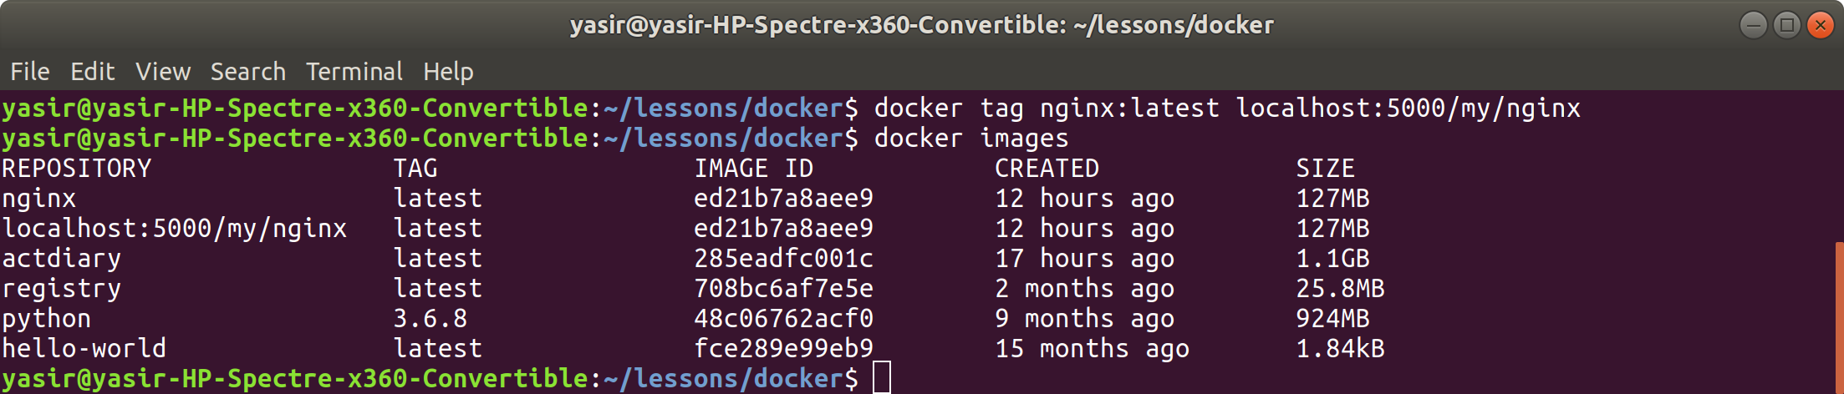

Use the docker push command to push the image to the Registry that you have created.

**$ docker push localhost:5000/my/nginx**

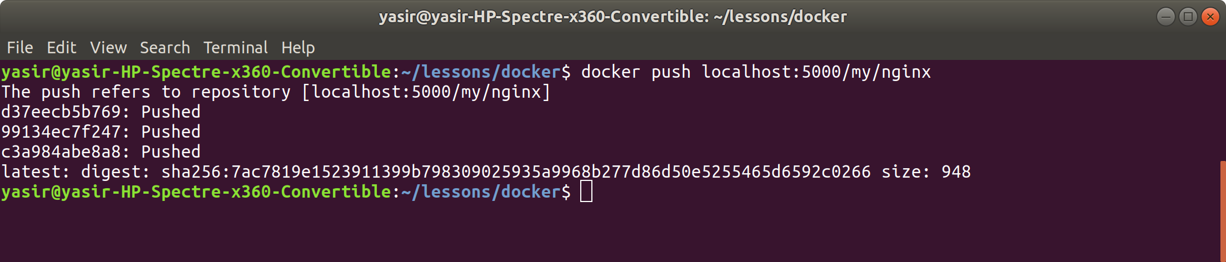

**Step 3: Download an image from the Registry**

Delete the NGINX images, both yours localhost:5000/my/nginx and the official nginx image.

The command for this is:

**$ docker rmi nginx:latest localhost:5000/my/nginx**

Check that the images have been removed from your local machine.

**$ docker images**

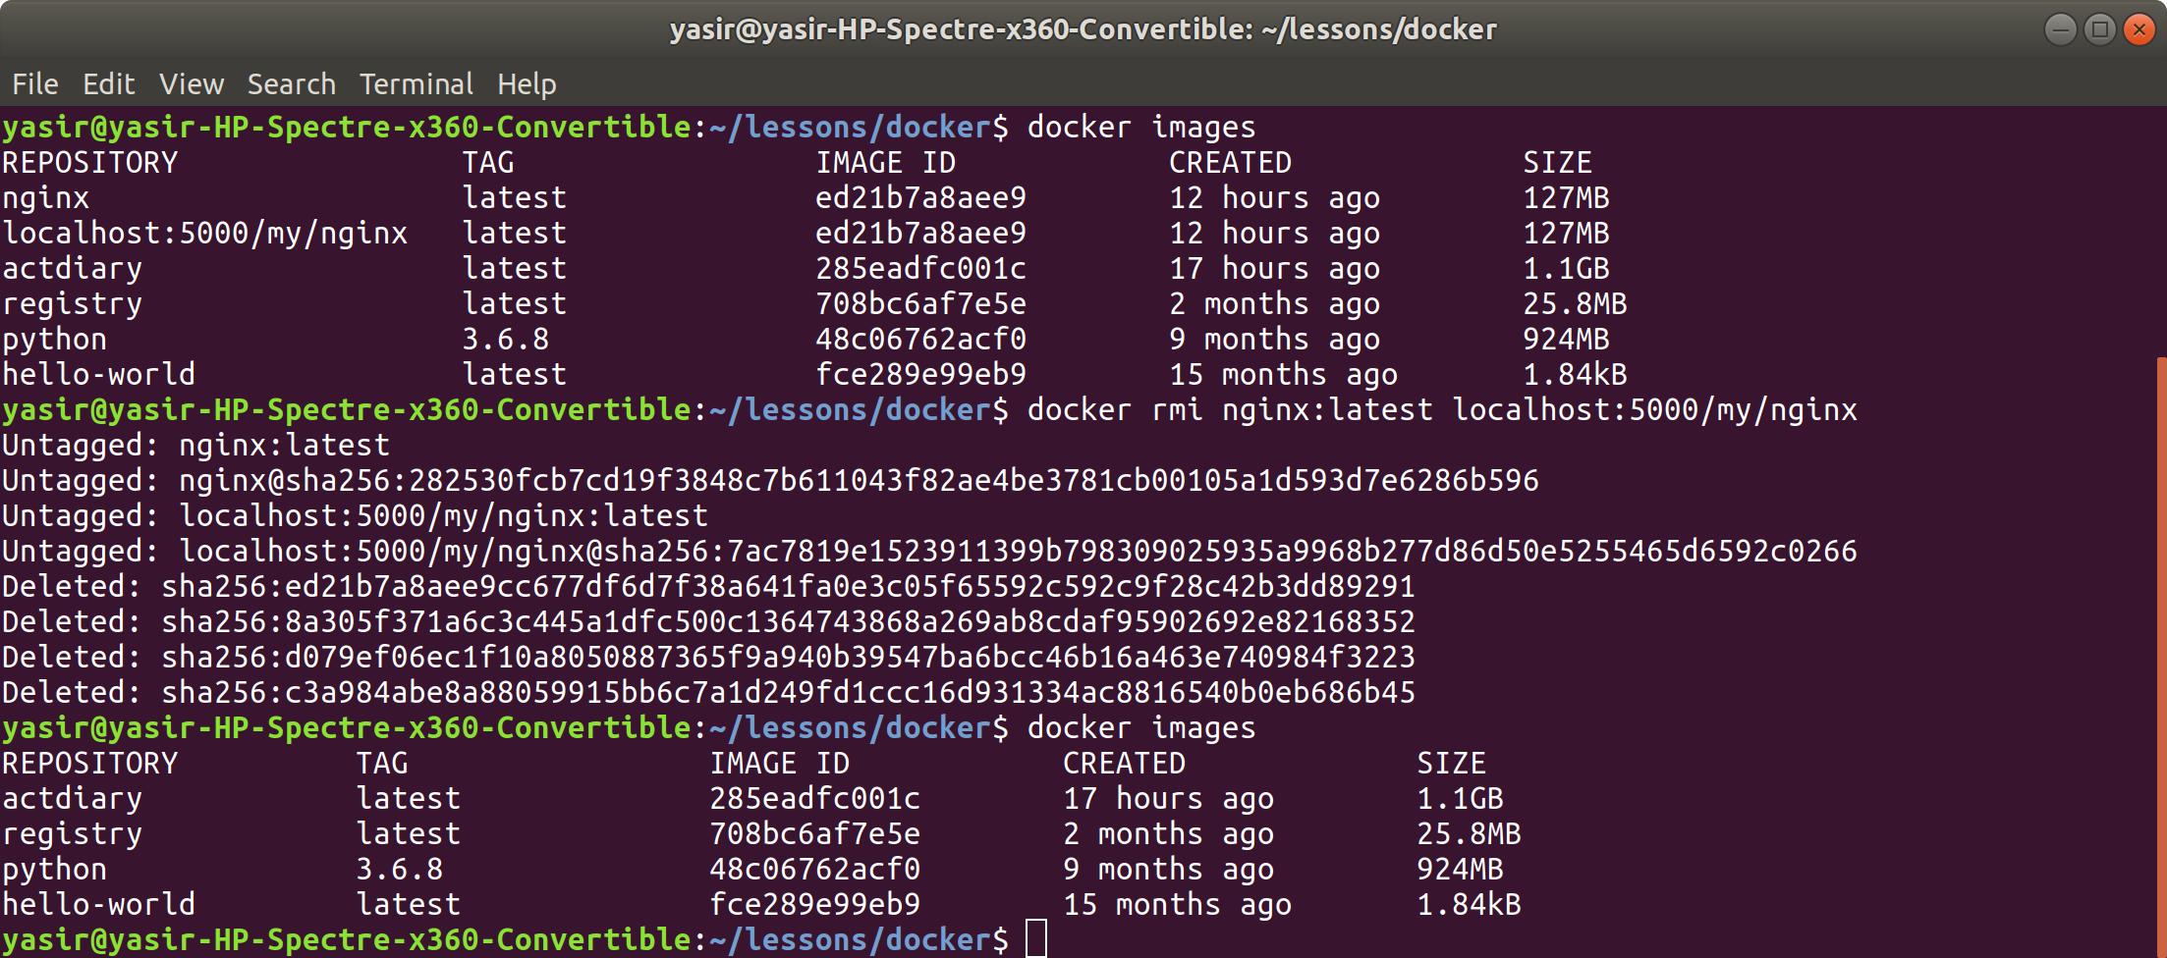

Now we can run a docker pull command to prove that the image has been stored in the Registry that we deployed, remember to pull you docker image as localhost:5000/my/nginx.

The command for this is:

**$ docker pull localhost:5000/my/nginx**

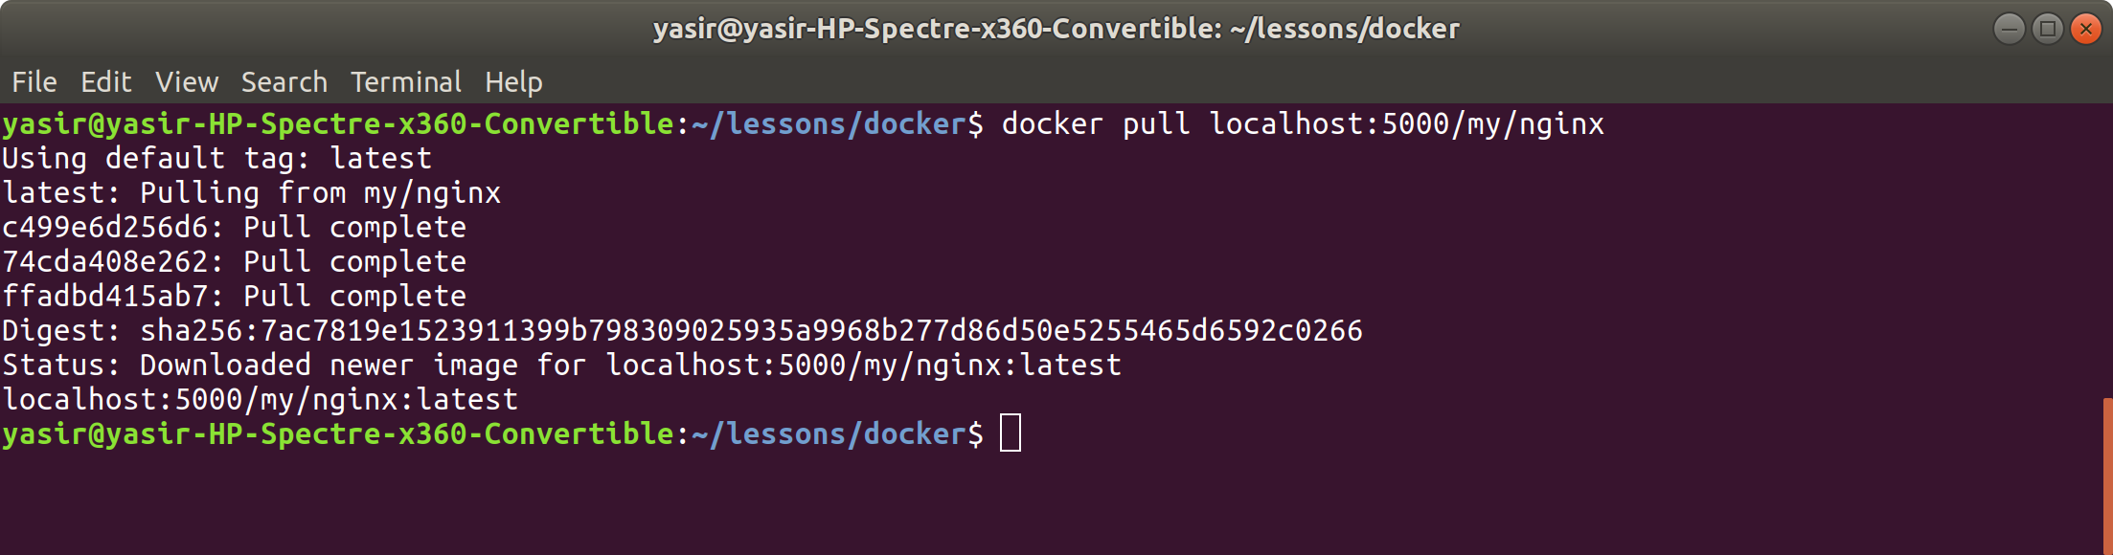

Check that the image has been pulled by executing:

**$ docker images**



**Step 4: Clean up**

Stop registry container:

**$ docker stop registry**

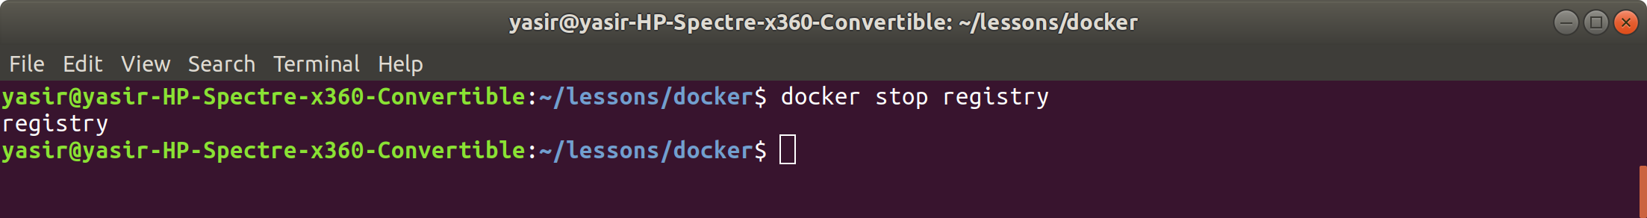

Remove registry container:

**$ docker rm registry**

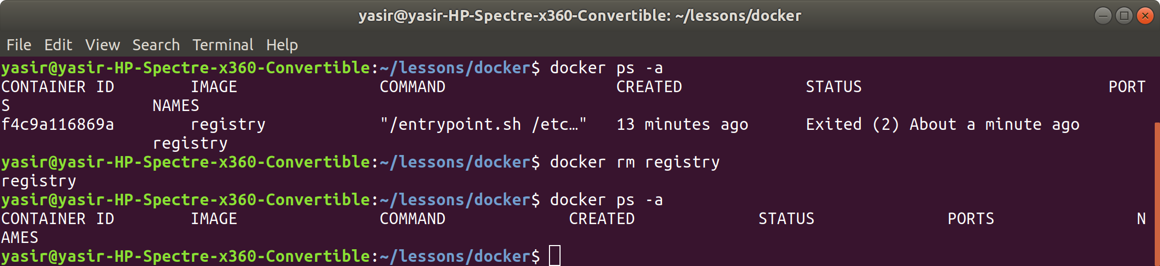

Remove images:

**$ docker rmi registry localhost:5000/my/nginx**

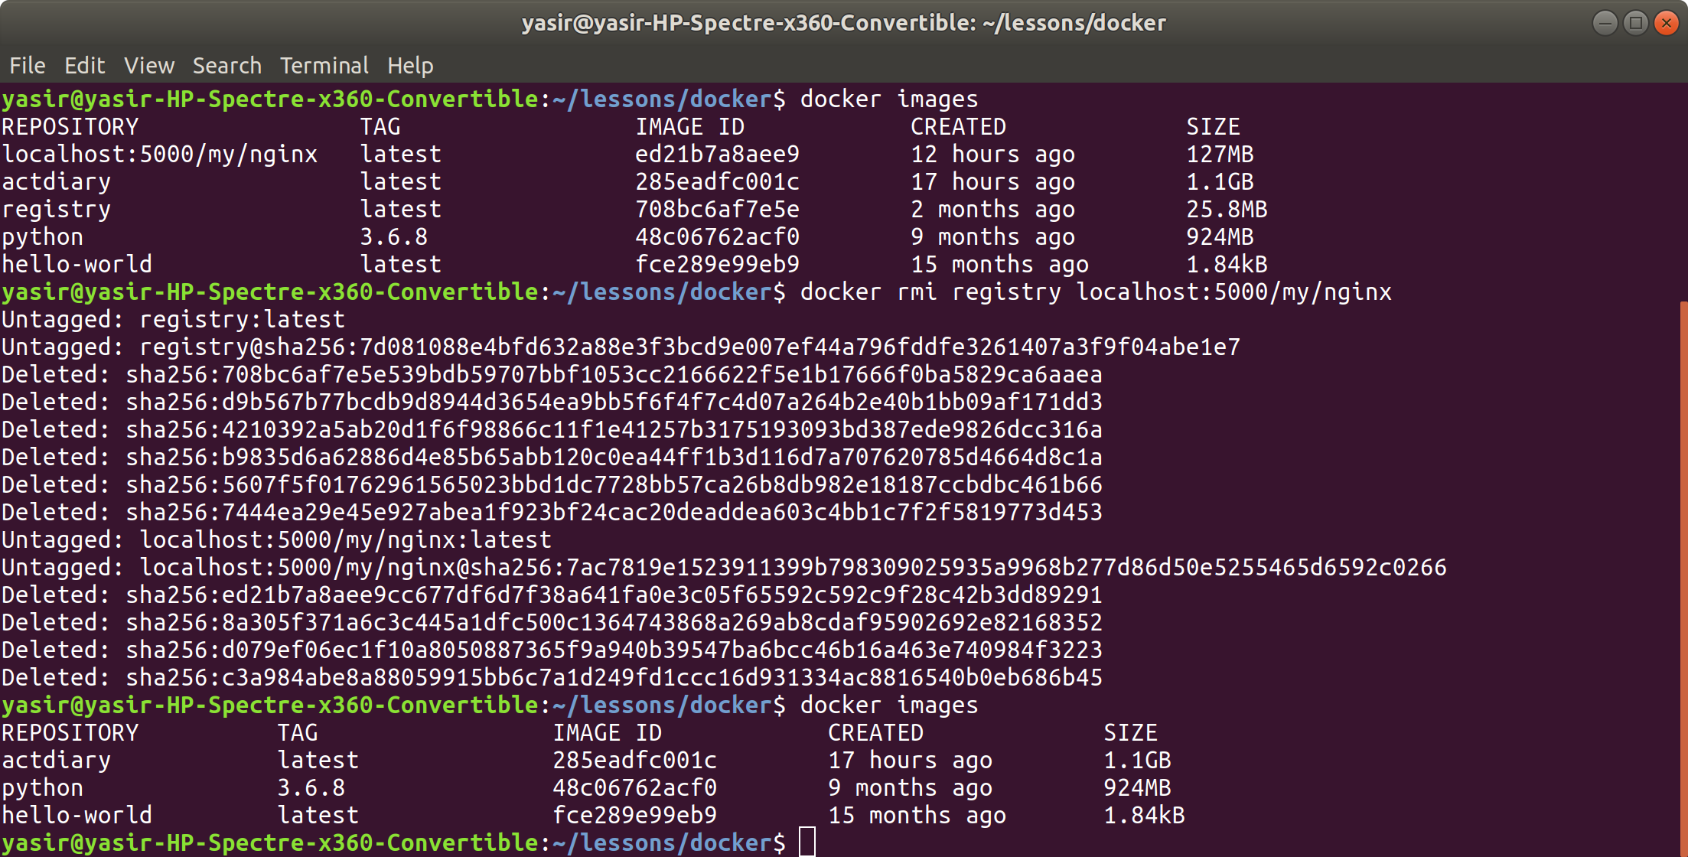

## Exercises

Expand individual task

Stop and remove all containers, remove all the images.

Try to create a shell script that can pull down a project from GitHub, build the Docker image and push it to the registry.

## 